- Open your own laptop or desktop (or use an online PC hardware simulator if you don't have access to a real system) and identify the GPU model installed. Write down the GPU's brand, model number, and whether it is integrated or dedicated.
GPU brand: Intel® UHD Graphics
GPU model number: WDDM 2.7
DirectX Version: 12(FL 12.1)
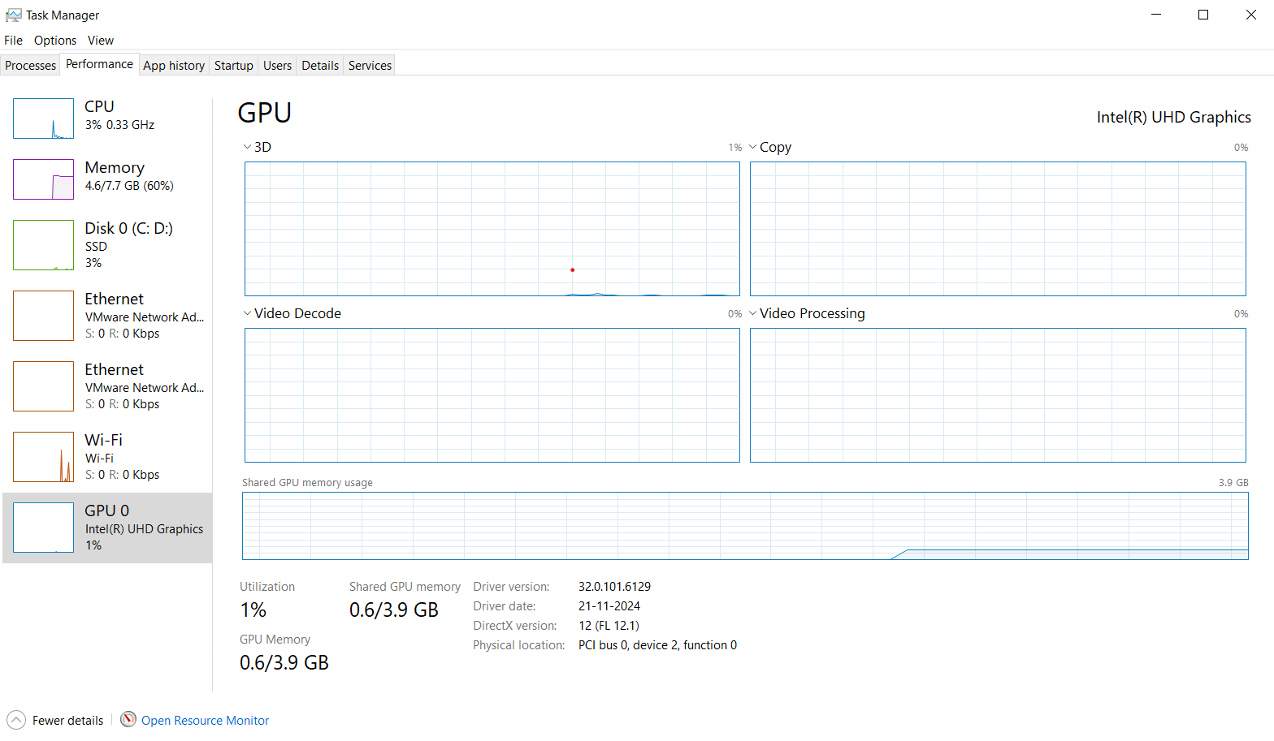

- Take a clear photo or screenshot of the cooling system (fan, heatsink, or liquid cooling setup) inside your PC or from a PC hardware simulator. Label the main cooling components and briefly describe their function.

- Air Cooling:
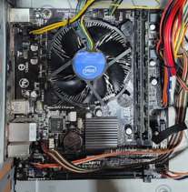
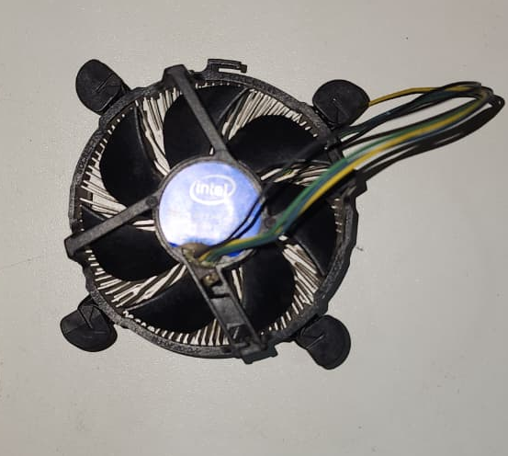
- An air cooling PC fan uses a metal heatsink combined with an electric fan to absorb and push heat away from your computer's processor (CPU) or out of the PC case.
Air cooling fan

- Create a comparison table listing at least 3 differences between air cooling and liquid cooling systems for GPUs, including factors like cost, efficiency, and maintenance.

- Air Cooling Vs Liquid Cooling

Factor | Air Cooling | Liquid Cooling
Cost | More budget-friendly and affordable upfront | Generally more expensive (especially custom loops or high-end AIOs).
Efficiency & Thermal Performance | Lower thermal conductivity; dumps heat inside the case, raising ambient temperatures. | Higher thermal conductivity and efficiency; keeps GPUs at lower temperatures (e.g., 46–54°C vs. 55–71°C) and supports heavy workloads or overclocking.
Maintenance | Low maintenance; primarily requires dusting the fins and fans every few months. | Higher maintenance; requires checking fluid levels, looking for wear on pumps/tubing, and managing potential leak risks.
Installation & Complexity | Simple and beginner-friendly setup with fewer failure points. | Complex installation requiring room for a radiator, tubes, and a water pump.
Noise Level | Can get louder under heavy loads as fans spin faster. | Typically quieter operation because larger or multiple fans can run at lower speeds.

- Imagine you are building a gaming PC for streaming IPL matches and playing graphics-heavy games. Choose between air cooling and liquid cooling for your GPU, and justify your choice in 3-4 sentences based on your research.

- For a high-end gaming and streaming PC, liquid cooling is the superior choice for your GPU. While air cooling is reliable and cost-effective, streaming graphics-heavy games pushes both the CPU and GPU to their absolute limits, generating massive amounts of sustained heat. Liquid cooling dissipates this thermal load much more rapidly and efficiently, preventing thermal throttling and ensuring consistently high frame rates during live broadcasts. Furthermore, liquid cooling operates much more quietly under heavy loads, preventing loud fan turbulence from bleeding into your stream microphone.

